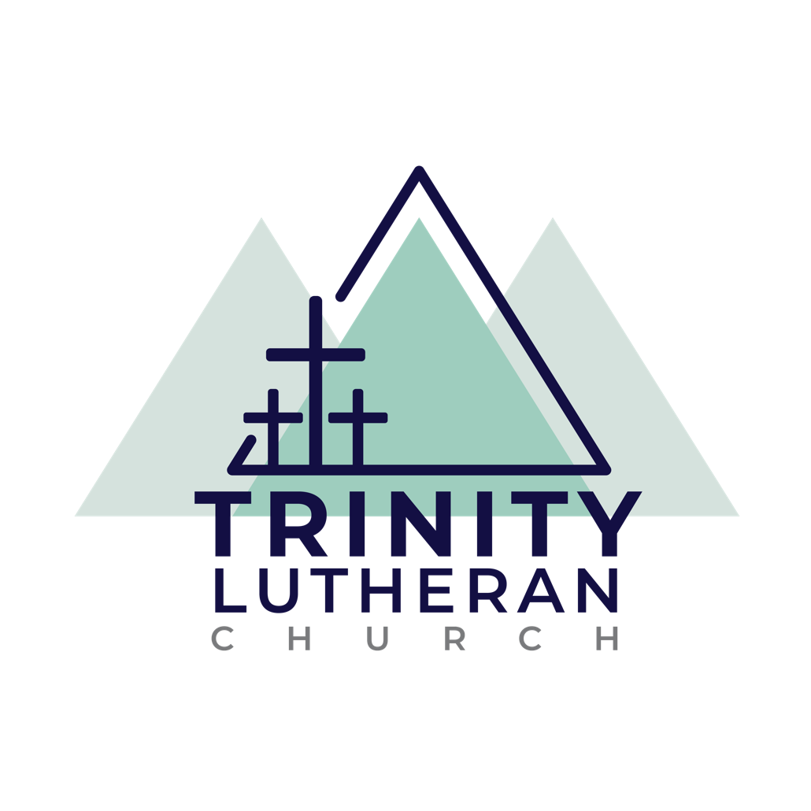

CONNECTING OUR COMMUNITY TO JESUS

Vision of Confirmation

As families of Trinity, we believe that we are called to Connect our Community to Jesus and that this happens through Worship, Discipleship, Fellowship, and Partnership. We desire to nurture students who know, are changed by, and can tell the story of God in their lives. We are then sent to serve as witnesses to the people around us.

Goals
- Students will grow in knowledge and understanding of Lutheran Doctrine.
- Students and adult members of the congregation will forge new peer and intergenerational relationships through meaningful interactions.
- Students will be equipped to become active participants in the life and mission of the church, growing in their understanding of Christian worship, discipleship, and partnership.

Objectives
- Students will be prepared to confess the faith, as described in Luther’s Small Catechism, during the Rite of Confirmation.
- Students will develop trusting and supportive relationships with a number of their peers, and with multiple adult members of the church through monthly meetings and other student ministry opportunities.
- Student ministry events will enable and encourage fellowship and service.
- Students will discover their place in the congregation through regular worship and Bible study attendance, sermon summaries, service projects, acolyting, etc.
- Lessons will have an emphasis on life application for students to analyze how they can incorporate Biblical and Catechetical teachings into daily life.
- Parents and guardians will be equipped with the tools to enable faith discussions in their household.

Confirmation is nothing new. From the time Jesus said to “go and make disciples and teaching them everything I have commanded you,”¹ Christians have been teaching the faith. “Confirmation, in the Early Church and today, is the Church’s response to Christ’s command to go and make disciples.² Throughout history, confirmation has undergone changes and struggles. Today one of its biggest struggles is how this process engages, equips, and educates a generation with more information, advantages, and technology than any previous generation.
In the Lutheran Church Missouri Synod, research has shown 70% of leaders are “unsatisfied” with confirmation; 57% of high school students upon completing the program had “low or moderate” satisfaction levels; only 23% of youth who were confirmed were “60-100%” still active in the church. ³ All of the leaders who were surveyed stated that there is a “need of greater parent involvement and commitment.⁴” Integrating the family into the Confirmation process helps not only to keep communication clear between church leaders and families, but also allows for the people of God to use the gifts that He has given to them. The Holy Spirit creates faith and feeds it, yet we must be mindful that He has given His people gifts for a reason.
Martin Luther at the beginning of each section of the Small Catechism writes, “In a simple way in which the head of a house is to present them to the household,⁵” signifying that 500 years ago parents/guardians were to teach their beliefs to the family. This has not changed. Parents and guardians still have the most impact upon their children’s faith.
Having support from friends and family is so important to this age group, especially at a time when students are searching for their identities. They need something stable and safe, but not so formal that they cannot be themselves. Students must be free to ask questions and encouraged to actively seek answers with help from others and on their own.

The Confirmation process at Trinity is designed to create that safe place and supportive atmosphere to strengthen these important relationships and engage our students and their families with the relevant teaching of Scripture so that they may better live purposeful lives in God’s Kingdom. Too often, Confirmation is viewed as an end or graduation. Through support of the congregation, friends and family, students will be able to identify that Confirmation is not an end, but a beginning. Confirmation must prepare these young students to encounter and live in a world that is influenced by the devil. Things seem to move fast and change faster. If they are not prepared to seek answers for themselves or taught not just the what but also the why of discipleship, then they will likely fall away from the church.

There will never be a perfect confirmation process. Each new generation of youth experiences unique changes and challenges. The Church is faced with the challenge of presenting the truths of Scripture in a way that the youth of today can identify and relate. The Confirmation program in our church seeks to bring the relevance of God’s Word into the lives of our students; taking into consideration the unique context in which they live. The Confirmation program at Trinity will incorporate different formats in the learning process, each in response to Christ’s Great Commission to “go and make disciples.”¹

1 Matthew 28:19-20 Holy Bible: New International Version. © 2003.
2 Bergman, Marvin. Confirmation Basics. Concordia Publishing House: St. Louis MI (8) ©2009.
3 Bergman, Marvin. Confirmation Basics. Concordia Publishing House: St. Louis MI (16-17) ©2009.
4 Bergman, Marvin Confirmation Basics. Concordia Publishing House: St. Louis MI (17) ©2009.
5 trans. Kolb, Robert and Wengert, Timothy J. Book of Concord: The Confessions of the Evangelical Lutheran Church. Augsburg Fortress. ©2000. 347-375

While faith-formation is a lifelong process, the formal process of “Catechesis” (teaching the faith in preparation for Confirmation) is a flexible length program at Trinity. The Confirmation Process is a faith process for young people (6th-12th grades), who want to dive deeper into understanding what they believe and why to participate in the confirmation “milestone” service at the end. The approach is “family-based,” while the group sessions and curriculum are paced in a two-year sequence, it can be completed as quickly as one year or as long as needed.
Together, students & a parent/mentor are invited to explore what it looks like to be followers of Jesus while working through Journal lessons, reading Scripture, and using the Catechism. At the end of the process, students are invited to publicly confirm and proclaim their identity as disciples who intend to continue to follow Jesus. Confirmation weekends are held on Reformation Sunday each year.
Students study Luther’s Small Catechism. We take this process seriously because we want confirmands to be confident when they confess the faith, “as taught in Luther’s Small Catechism.”
Year | Overview
Bible Basics | We hope that our incoming conformation students will learn Bible basics through our Kids’ Crew Discipleship program during their childhood as they read through the Old and New Testaments. The Old Testament is covered beginning on even-numbered years, and the New Testament on odd. As we know that all students do not participate in Kids’ Crew or may not have had the opportunity, we work individually with students on gaining a foundational understanding of the Bible throughout their confirmation process.
Cycle 1 | Catechumens explore the meaning of the 10 Commandments, Elements of Worship and the Church year and Apostles Creed. This year of Catechetical instruction begins on odd-numbered years.
Cycle 2 | Catechumens explore meaning of the Lord’s Prayer, Confession/Absolution Sacrament of Holy Baptism, Sacrament of Holy Communion, This year of Catechetical instruction begins on even-numbered years.
Capstone | Confirmands will complete their study with a review of the six chief parts and discussion of The Office of the Keys, Vocation, and the Rite of Confirmation.
At the Rite of Confirmation, students become members of the congregation. To prepare for a future of active adult participation in the life and mission of the congregation, students will attend worship regularly, focus on the sermons in worship, acolyte, and explore various ways to serve the community and congregation by completing service hours. Our process is an individualized and personalized experience and goals will be set during the confirmation kick off each fall in August.

Year | Milestone or Event
Year 1 (5/6/7/8) | Students are eligible to consider communion preparation classes and receive first communion on Maundy Thursday. Choosing to participate indicates the student will begin confirmation the following fall. Students DO NOT need to participate in communion to start confirmation, they may participate in this training at any time 5th grade and up.
Year 2 (6/7/8 grade) | Students are invited to attend attending Sunday Small Group sessions (with parents on the 3rd week of the month) and discussions based on video lessons.
Year 3 (6/7/8 grade) | Students continue catechism Sunday Small Group sessions (with parents on the 3rd week of the month) and discussions based on video lessons.
Year 4 (8/9/10 grade) | Students complete their catechism instruction.  Confirmands prepare a “Statement of Faith” to be shared with the whole congregation during worship and design a stole.  Students participate in the Rite of Confirmation on Reformation Sunday.
Post (High School) | Students are encouraged to grow in faith through worship attendance, regular Bible study, high school youth activities, and staying connected to the ministry of Trinity.

Group Session Attendance, Journals and Check ins
- All students are expected to attend Group sessions and complete 100% of check in sessions.
- If you are unable to attend a Sunday Group session discussion, video lessons stored on YouTube @TrinityChildrenandFamily are still available for you to complete with your family.
- We ask that students complete an annual goals/intake sheet and check in reflections after each section. Follow up Check ins will be scheduled between the student and DCE/Pastor following each submission. Parents are encouraged to assist with journals and check ins as their students have questions. This helps keeps parents and guardians primarily responsible for Confirmation instruction, as Luther intended and as God designed.

Worship Attendance
Our weekly worship is where God feeds us with His precious Word and Sacraments (see Matthew 4:4). We ask students to set a goal for attending worship at the beginning of each year. In general, we encourage students to work toward 75% of worship attendance as the goal by their capstone year a way of getting into the routine of consistent worship attendance.

Sermon Summaries are a tool enabling families to discuss worship and faith throughout the week and at home. Students (and parents) will set goals for sermon summaries and format for submission during the fall goal setting retreat. We do not have a set or required number but are looking for parents to help guide discussions and meaningful application of the concepts.

Journal Entries and Check Ins
All students will receive a confirmation Journal that aligns with monthly group sessions Students are encouraged to complete Journaling activities in a self-paced manner keeping up with the suggested scope and sequence in our schedule. Parents are invited to review the journal questions and provide support, but journals WILL NOT be submitted. They are for at home use only.

At the end of each Journal section, students will submit a check in sheet and schedule a time to meet with the DCE/Pastor to discuss questions, goals, and provide resources.

Our expectation is that 100% of check ins is complete by June. We trust parents help support this goal in the way that works best for their family schedule. This gives families the flexibility to use these assignments for learning and discussion as suits each child. Note that conceptual understanding of topics is more valuable than rote memorization.

Serving in Worship
All 5th-8th students will be asked to serve in our worship services as acolytes, ushers, readers, greeters or tech and music. As we know that we all have different gifts, considering best roles and goals for how often will also be discussed in the annual goal sheets. Acolyte sign-ups are in the sanctuary and students can sign up monthly. Other serving roles are scheduled through our Realm app and front office. After the fall retreat students will be added to the rotation in teams they select. When scheduled to serve, please arrive 10 minutes before the start of the service.

Serving in the Church and Community
We serve God by serving others. Using our gifts to serve others in our home, church, school and community is something Christians do because we “get to,” not because we’ve “got to.” Serving allow you to practice living out your Christian faith. During the annual goals session, students will consider ways they can use their gifts and set goals for the year. Completed serving reflection forms (located by the DCE’s office) are due by the day of Confirmation.

Statement of Faith
In the fall, those who are ready to be confirmed will write a personal statement of their faith that he or she will share with the whole congregation during worship. Each of these will focus on how God has influenced his or her own faith development and what they have learned through their Confirmation experience. This step also often includes the selection of a personal Confirmation Verse.

Pre-Confirmation Interview/Visit
Before students are confirmed - there will be a pre-Confirmation interview/visit as a final check in with one of the Pastors or the DCE. Do not be worried; this is meant to be a helpful visit that gives you an opportunity to talk about your faith and share any reservations. The Pastor or DCE will ask you questions about what you have learned and will review the vows you will be making during the Rite of Confirmation. Please respond honestly and from your heart.

CONFIRMATION OUTLINE 2023- 2024
Cycle One Students

Month | Group Session | Journal Sections | Check In
August | Saturday, August 19  1pm – 4pm  Kick Off Option 1 | 1.1 – 1.8 | Check in 1 at Retreat
September | Sunday, September 17  9:30 am  10 Commandments 1  Sunday, September 17  12:00pm – 3:00pm  Kick off Option 2 | 2.1 – 2.7  1.1 – 1.8 | Intake/Goals Sheet  Check in 1 at Retreat  Check in 2 after complete
October | Sunday, October 15  9:30 am  10 Commandments 2 | 2.8- 2.13
November | Sunday, November 12  9:30 am  10 Commandments 3 | Section 1 & 2 Catch up/Completion | Check in 3 after complete
December | Sunday, December 10  9:30 am  Lutheran Worship | NONE
January | Sunday, January 14  9:30 am  Apostles Creed 1 | 3.1 – 3.4 | Submit Serving and Sermon Notes Reflections
February | Sunday, February 11  9:30 am  Apostles Creed 2 | 3.5 – 3.8
March | Sunday, March 10  9:30 am  Apostles Creed 3 | 3.9 – end of section 3 | Check in 4 after complete
April | Sunday, April 14  9:30 am  Wrap Up | Section 3 Catch Up
May | May TBD  End of Year Celebration |  | Final Reflection, Sermon notes and Serving Reflections

CONFIRMATION OUTLINE 2023
Fall Confirmands

Month | Group Session | Journal Sections | Check In
August | Saturday, August 19  1pm – 4pm  Kick Off Option 1 | Faith Habits 1-2  8.1 -8.2 | Intake/Goals Sheet at retreat
September | Sunday, September 17  12:00pm – 3:00pm  Kick off Option 2  Sunday, September 24 | Faith Habits 1-2  8.1 -8.2  Faith Habits 3-4  8.3 -8.4 | Intake/Goals Sheet at retreat  Pick Confirmation Verse  Pick up Stole Items
October | Sunday, October 1  Sunday, October 8  Sunday, October 15  Sunday, October 22  Sunday, October 29 | Faith Habits 5-7  8.5 -8.7  Lesson 8.8 | Check in 7 Complete  Faith Statement Drafts  Stoles and Faith Statements Finished  Rite of Confirmation
November | Dates TBD by student |  | Post Confirmation Check in for Each student

